SIMATS ENGINEERING
ASSESSMENT TOOL 3

COURSE NAME: COMPUTER ARCHITECTURE COURSE CODE: CSA12

COURSE OUTCOME COVERED

CO1: Analyze the functional units of a computer system including CPU, memory, bus structures, and I/O components by examining instruction execution cycles, addressing modes, and performance metrics such as CPI, clock cycles, and benchmarking (BL4)
Assessment Tool Weightage: 40%

QUESTIONS:5 Total Marks:25

ANNEXURE A
CODING CHALLENGE

Code of Conduct:

I __B.Samuel Jadon(192571042)___ (Name / Reg No) certify that this submission is my original work and that I have adhered to the guidelines specified for this assessment.
I understand that any violation of academic integrity rules will result in disciplinary action.

Signature of the student:

ANNEXURE A
- Write a program that simulates a CPU performing the operations:
- Fetch
- Decode
- Execute
- Store
Input:
ADD 15 20
Output:
Fetched Instruction
Decoded as ADD
Executed Result = 35
Stored in Register

- Given a sequence of CPU instructions, count how many times memory is accessed.
Example Input
LOAD
ADD
STORE
SUB
LOAD
STORE

Expected Output

Memory Reads = 2
Memory Writes = 2
- Write a program that simulates the execution cycle of a CPU. For each instruction, display the five stages of execution:
- Fetch
- Decode
- Execute
- Memory Access
- Write Back

Input
LOAD R1
ADD R2
STORE R3

Expected Output
Instruction: LOAD R1
Fetch
Decode
Execute
Memory Access
Write Back

Instruction: ADD R2
Fetch
Decode
Execute
Memory Access
Write Back

Instruction: STORE R3
Fetch
Decode
Execute
Memory Access
Write Back
- Exchange the contents of Registers B and C.
INPUT
Before
B = 25H
C = 60H
After
B = 60H
- i. Add two 8-bit numbers stored in memory locations 2500H and 2501H, and store the result in 2502H.
ii. Subtract the number stored at 2501H from the number stored at 2500H and store the result in 2502H.

8086 Program: Subtraction of Two 8-bit Numbers

Problem
Subtract NUM2 from NUM1.

1)
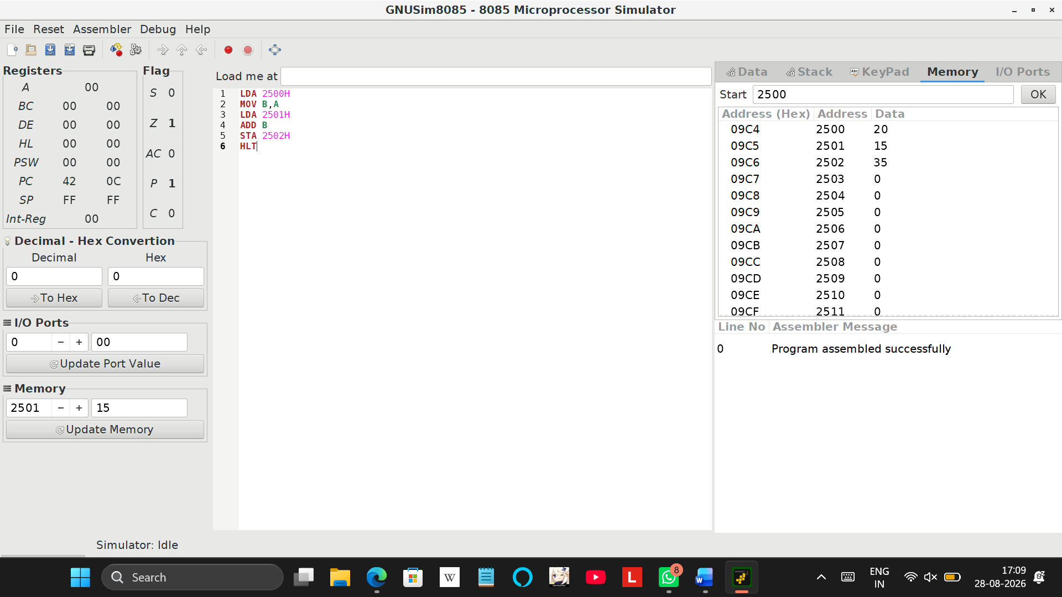

2)
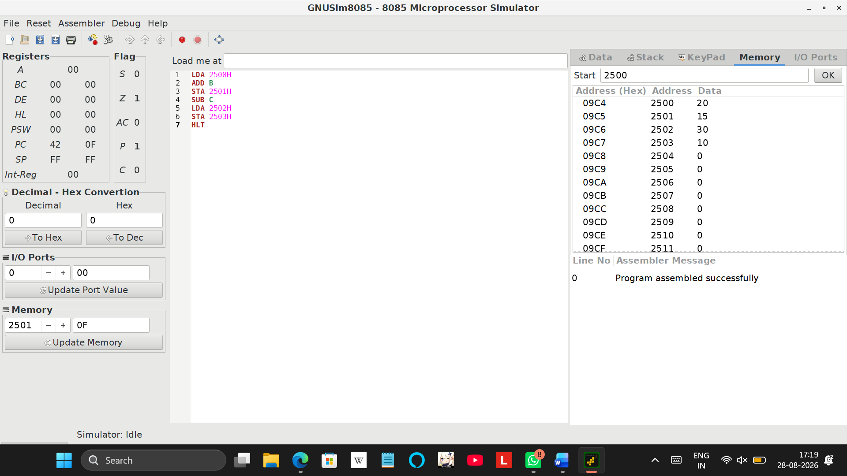
3)
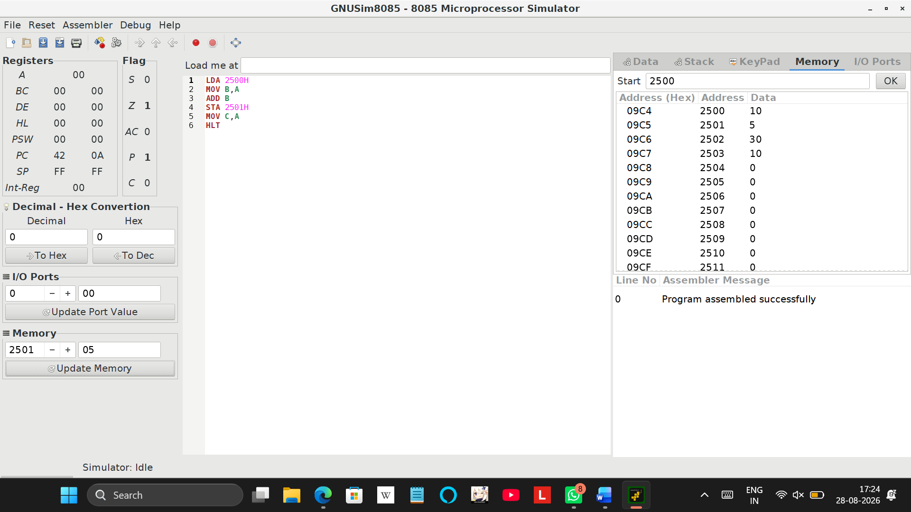

4)
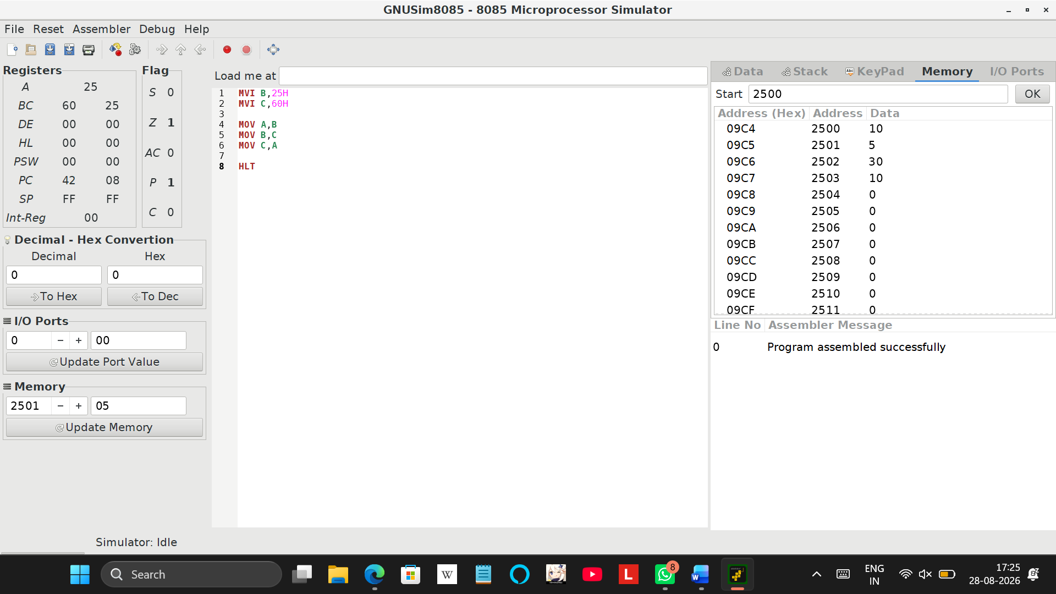
5)
i)
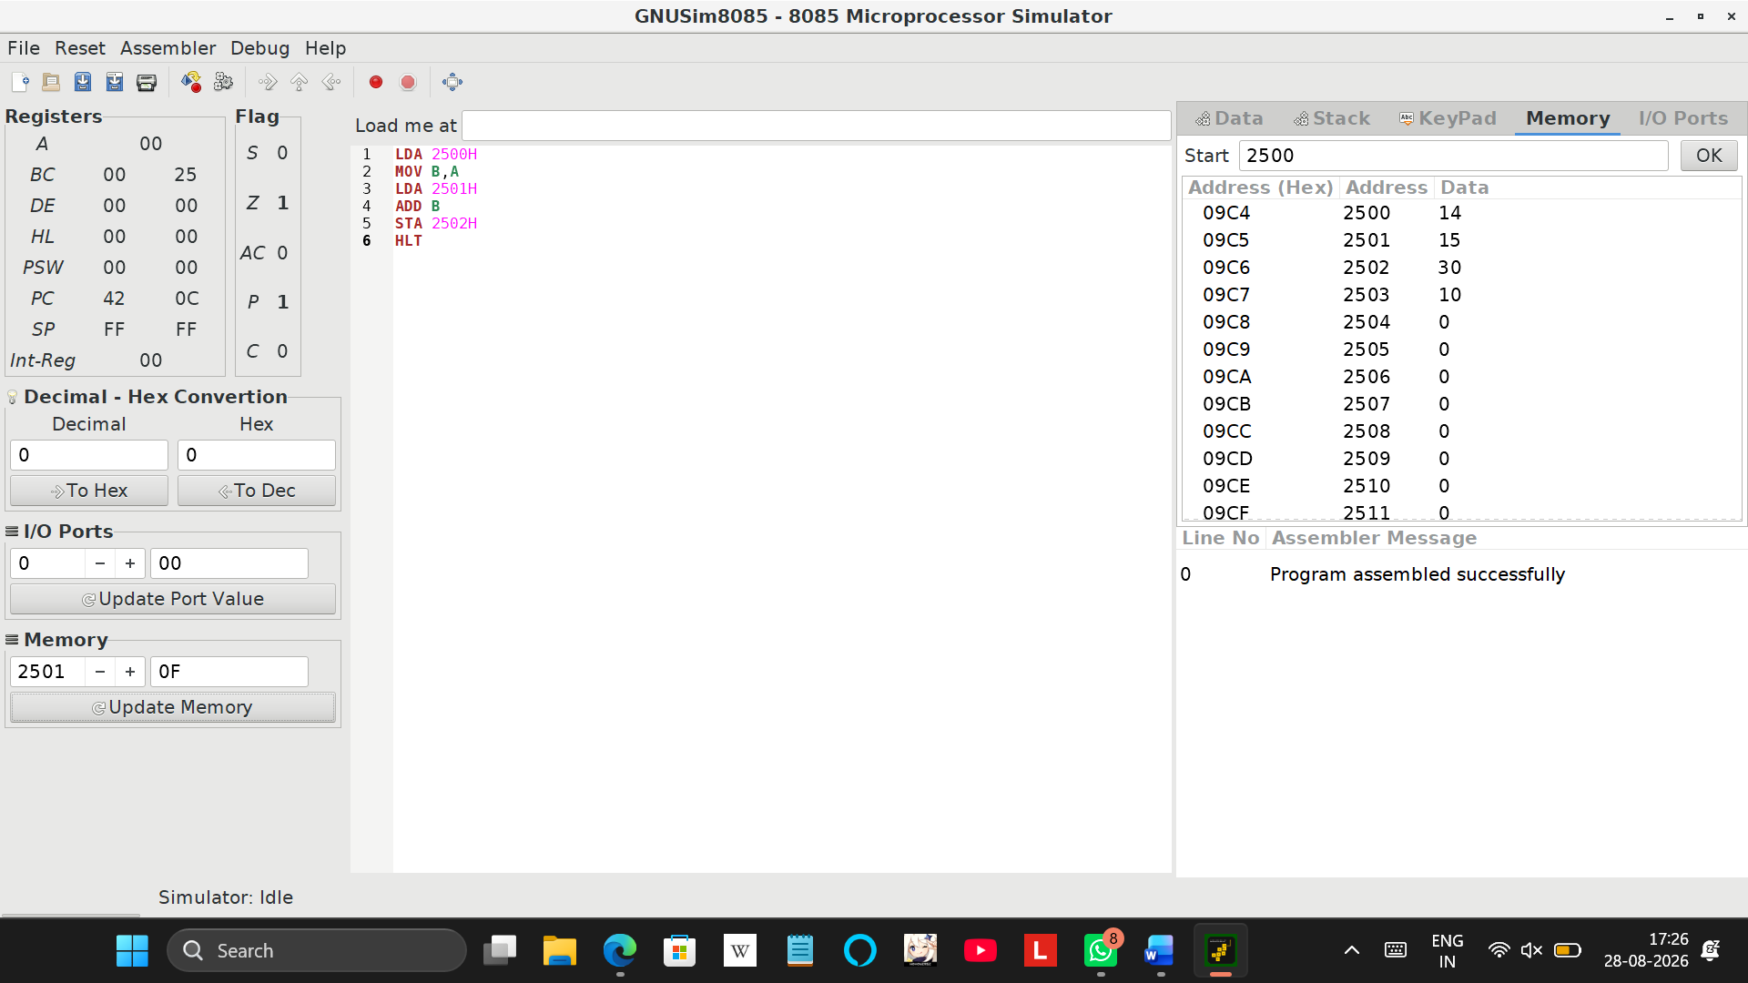
ii)
